**Second Year Mini Project Report**

Submitted in partial fulfillment of the requirements of the

degree

# BACHELOR OF ENGINEERING IN COMPUTER

**ENGINEERING**

By

**Rahul Kithani - 40**

**Manish Motwani - 31**

**Mohit Advani - 02**

**Varun Dulani- 21**

Supervisor

**Mrs. Manisha Mathur**



**Department of Computer Engineering**

**Vivekanand Education Society’s Institute of Technology**

# HAMC, Collector’s Colony, Chembur,

**Mumbai-400074**

**University of Mumbai**

**(AY 2023-24)**

# CERTIFICATE

This is to certify that the Mini Project entitled **“ HemaLink:Connecting Lifesavers” by Rahul Kithani(40),Manish Motwani(31),Mohit Advani(02), Varun Dulani(21)** submitted to the University of Mumbai in partial fulfillment of the requirement for the award of the degree of **“Bachelor of Engineering”** in **“Computer Engineering” .**

**(Mrs. Manisha Mathur)**

Supervisor

**(Dr. Nupur giri)** head of department

**(Dr. J. M. Nair)** Principal

# Mini Project Approval

This Mini Project entitled “ HemaLink:Connecting Lifesavers**” )** by **Rahul Kithani(40), Manish Motwani(31), Mohit Advani(02), Varun Dulani(21)** approved for the degree of **Bachelor of Engineering** in **Computer** **Engineering.**

**Examiners**

**1………………………………………**

(Internal Examiner Name & Sign)

**2…………………………………………**

(External Examiner name & Sign)

Date:

Place:

**Contents:**

* **Abstract**
* **Acknowledgments**
* **ListofAbbreviations**
* **ListofFigures**
* **ListofTables**
* **ListofSymbols**

1. **Introduction**   **1 1.** Introduction
   1. Motivation
   2. Problem Statement &Objectives
   3. Organization of theReport
2. **LiteratureSurvey**
   1. Survey of ExistingSystem
   2. Limitation Existing system or researchgap
   3. Mini ProjectContribution
3. **Proposed System (eg New Approach of DataSummarization )**
   1. Introduction
   2. Architecture/ Framework
   3. Algorithm and ProcessDesign
   4. Details of Hardware &Software
   5. Experiment and Results
   6. Conclusion and Futurework.

## Abstract

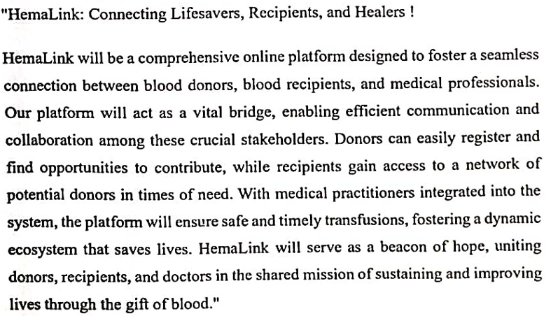

## Acknowledgement

We would like to thank and express gratitude to all those who contributed and supported us to plan our project smoothly and successfully.

We would like to express our gratitude towards Dr. J. M. Nair, Principal of V.E.S.I.T for her immense support and motivation.

Firstly, we would like to thank Dr. Nupur Giri, Head of Department, Computer

Engineering of V.E.S. Institute of Technology, for her guidance. We are whole-heartedly thankful to her for giving us their valuable time and knowledge to make us understand the executing process and hence providing a systemic planning of our project in time.

We express our immense gratitude to Mrs. Manisha Mathur for her constant guidance and valuable suggestions which made us complete the execution of

our project successfully. Her guidance and pattern of teaching made us capable enough to plan the project systematically and efficiently.

We would also like to extend our gratitude to all the faculty members who have not just been

a constant source of support, but also encouraged us for timely completion of assigned execution activity.

Lastly, we would like to acknowledge our classmates, who have also provided us with every possible support and learning to execute our project efficiently.

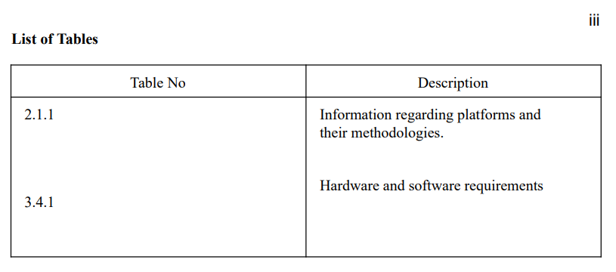

**Chapter 1**

### Introduction

This chapter explains the aim, objectives and scope of the proposed system.

#### 1.1 Introduction

Blood transfusion safety remains an important public health concern in India. The availability of blood products of all blood types and the provision of its safety ensure public trust of its healthcare system. However, lack of availability of these blood products and provision of unsafe blood products still impact morbidity and mortality. Through the use of online blood bank management system, blood transfusion safety is expected to be enhanced or improved. Risks on improper blood donors’ documentation, and misplaced records can be minimized or totally avoided. Also, processes involving blood bag collection, storage, and inventory will be systematized and organized, hence, improving the healthcare management.

#### 1.2 Motivation

The motivation to create a blood bank management website is driven by the desire to save lives, enhance efficiency in blood donation and distribution, raise awareness, build trust, and leverage technology for a noble and impactful cause

#### 1.3 Problem Statement & Objectives

Problem statement:

Our website aims to design, develop and implement online blood bank management system.

Objectives:

1] To ensure hospital to have good supply or inventories of blood bags. 2] To check the availability of blood bags anytime.

1. To manage the information of its blood donor.
2. Function to check if the person donated blood in the last 3 months. 5] To allow good documentation about the donor and its blood donation activities. 6] Support fast searching to find match blood bags for the right person.

#### 1.4 Organization of the Report

This report consists of three chapters. The first chapter deals with introduction of the topic, problem statement, motivation behind the topic and objectives. The second chapter is the Literature Survey. It includes all the research work done related to this topic. All information related to study of existing systems as well as learning of new tools is mentioned in this chapter. The third chapter is about the proposed system which is used in this project. The block diagram, techniques used, hardware and software used screenshots of the project are presented in this chapter. All the documents related to development of this project are mentioned in References

## Chapter 2

### Literature Survey

#### 2.1 Survey of ExistingSystem

Donor Registration: Users can create profiles, providing their personal information, blood type, and contact details.

Blood Availability: Real-time tracking of available blood units, including blood type, quantity, and expiration dates.

Appointment Scheduling: Donors can schedule appointments to donate blood at nearby blood banks or mobile donation drives.

Request and Order Blood: Hospitals and medical facilities can request blood units online, specifying the required blood type and quantity.

Inventory Management: Blood banks can manage their inventory efficiently, tracking donations, storage conditions, and expiration dates.

##### 2.2 Limitation of existing system

Digital Divide: People in underprivileged or rural areas may have limited access to the internet or may not be familiar with using online platforms, making it challenging for them to participate.

Emergency Response: There is no existing website to quickly mobilize donors and volunteers

during emergencies, natural disasters, or critical shortage.

**2.3** **Mini Project Contribution**

We have an additional rapid response feature in our website which can be used in emergency situations. Rapid Response: Our platform is equipped with a swift and dynamic 'Rapid Response' feature, ready to spring into action during emergencies, natural disasters, or times of critical blood shortages. We ensure the immediate mobilization of donors and volunteers, making a lifesaving difference in moments of urgency.

## Chapter 3

### Proposed System

This chapter consists of detailed description about the methodology used, the hardware and software components, the tools used and also the screenshots of the project

#### 3.1 Introduction

We were able to design, and develop our online blood bank management system website using PhP and MySQL for the back-end database and HTML and CSS for Front-end database.

##### 3.2 Architecture

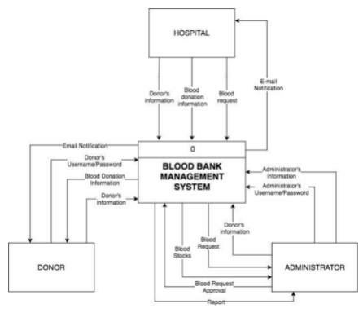

##### 3.3 Algorithm and Process Design

1. **Formulating the Problem statement:**

The 'BLOOD BANK MANAGEMENT SYSTEM' project is to interconnect

all the blood banks, hospitals, donors into a single network, validation, store various data and information of blood of each individual.

1. **Understanding the framework and requirements:**

It is a systematic approach for maintaining blood supply and avoiding any hassle at the time of requirement. It keeps all the records about donors, donations, receiver, time and date, nearby hospitals, closest blood banks.

Thus, providing ease for donors and receivers.

1. **Identifying tools/technology to be used:** Solar Powered Blood Bank Refrigerators Solar-powered blood bank refrigerators provide sustainable and reliable blood storage solutions, especially in remote areas where the power supply is inconsistent. These refrigerators are powered directly by solar energy.
2. **Finalizing the features to be included:**

1.Blood Collection Management

2.Stock Management

3.Records of Donors and Receivers

1. **Development:**

An online website to help save lives.

**6.Testing :**

Software testing which involves the execution using xampp software.

**7. Evaluation:**

Working properly.

##### 3.4 Details of Hardware & Software

Hardware :

Windows 8/8.1/10/11 (64-bit)

CPU: Intel Core i5-8400 3.0 GHz or higher

Memory: 8GB or higher RAM

Free Storage : 15GB or higher (SSD is strongly recommended) Software :

Visual Code

Xampp

Chrome

**3.5 Results**

 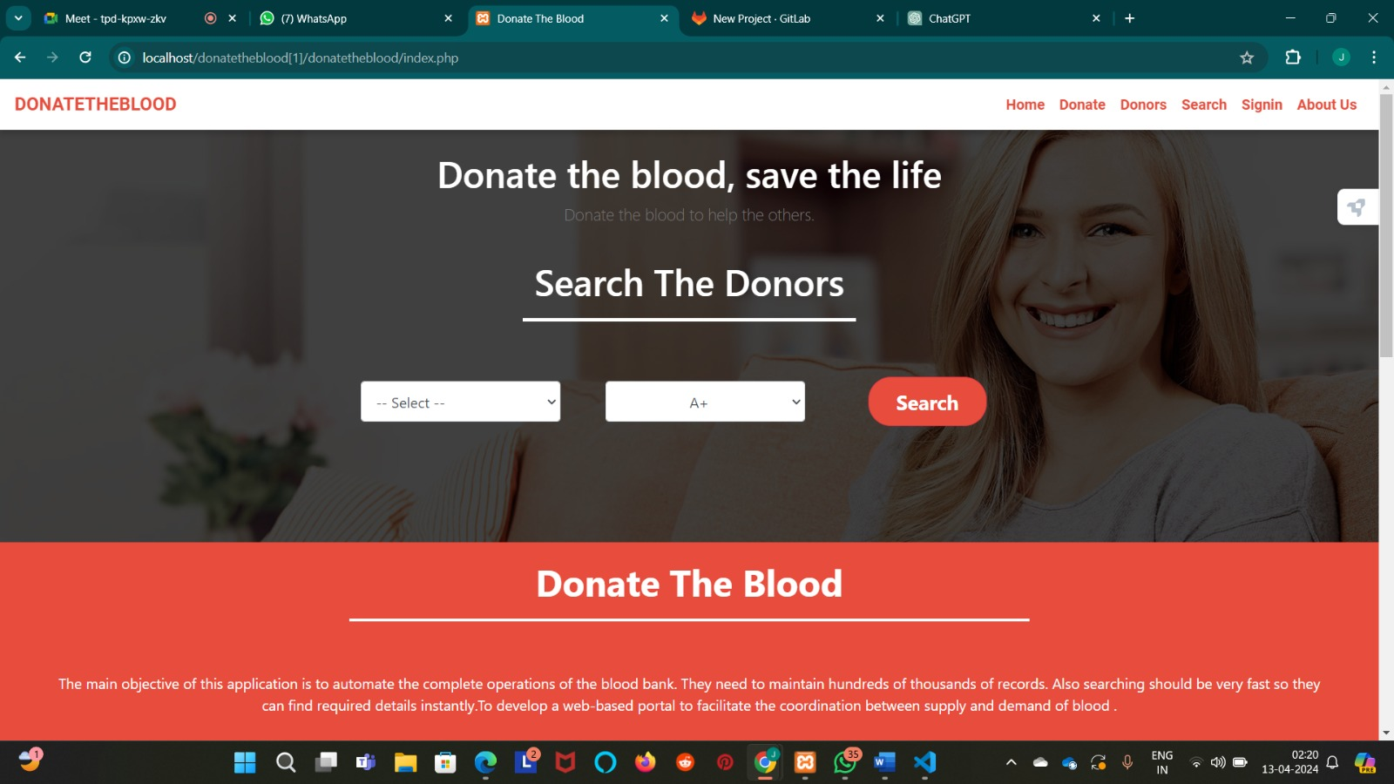

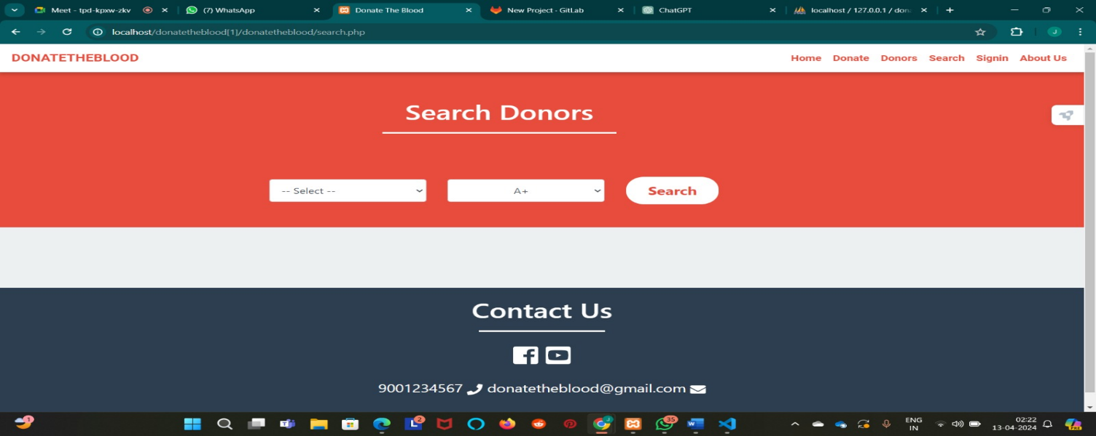

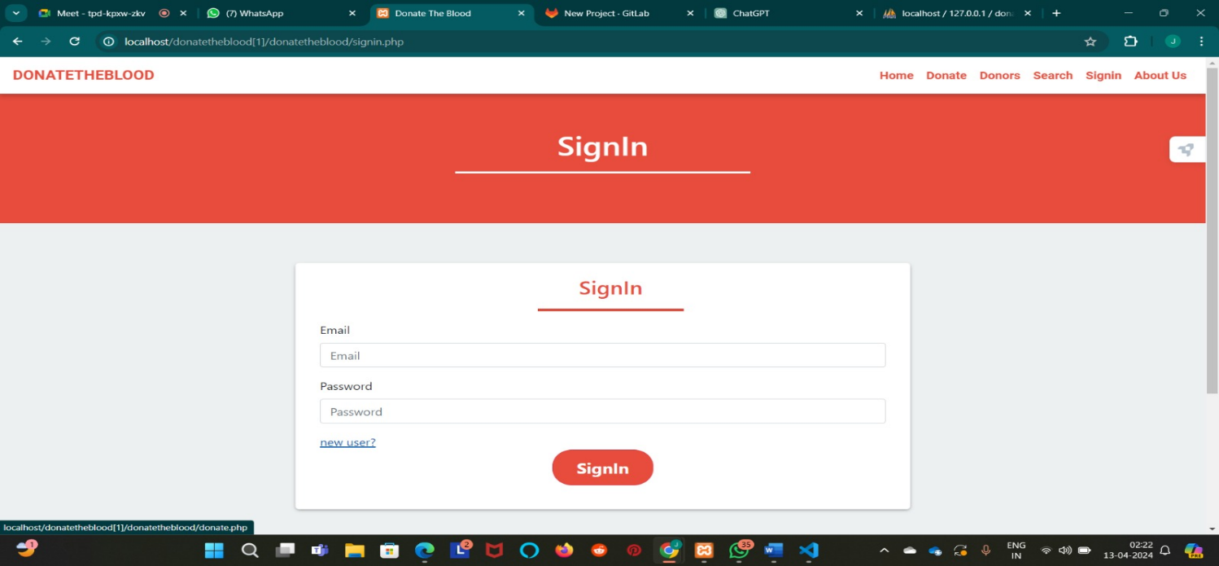

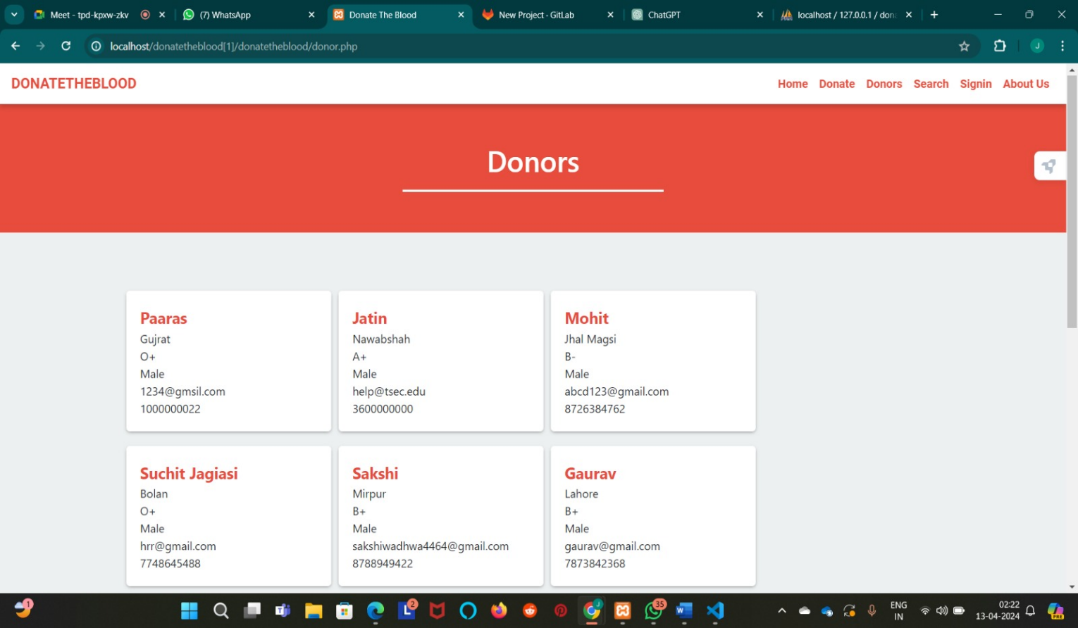

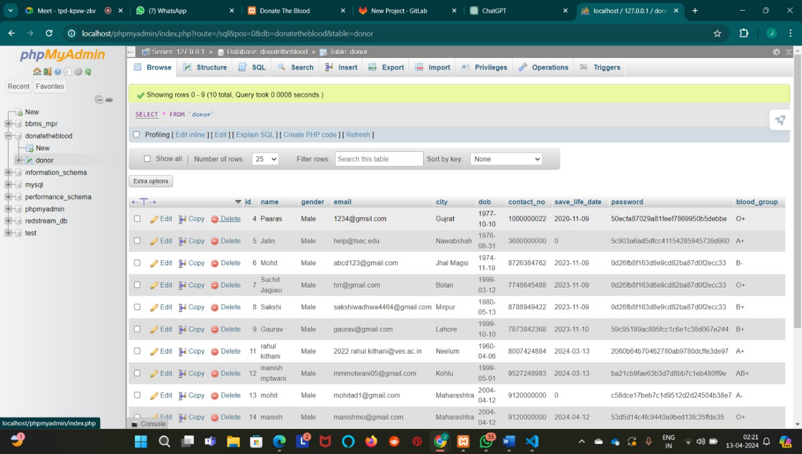

##### 3.6 Conclusion and Future Work

Based on results, this study concluded that online blood bank management system is much better than the manual system. The findings showed that respondents prefer to use online blood bank management system rather than the manual system because it offers many advantages and benefits that lead to its effectiveness, and efficiency. Because of the increased confidence on the users on the system, it can be concluded that the online blood bank management system enhances blood transfusion safety because it provides better ways of handling the various processes in blood bank.

We have already entered the age of Information Technology, where all the paper work / manually managed files are about to finish, now with the help of this user friendly software all the files stored in the computer can be very well formatted. With little more modifications it will become the good software for Blood Bank. The present ‘Blood Bank' project may be further developed for more complex transactions and to meet the requirements of modern day dynamic System

Operation New options and their respective implementation may be done for this purpose

#### References

http://www.bharatbloodbank.com[1]. http://www.lionbloodbank.net[2].

https://www.who.int[3]